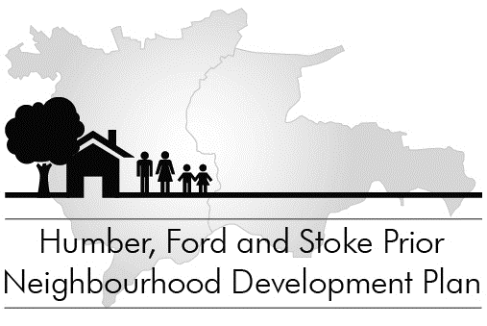

Neighbourhood Plan Public Consultation
1 August to 15 September 2015

Our Neighbourhood Plan will shape our community for the next 15 years

The draft Plan is being delivered to residents and is also available on the NDP webpages at www.hfspgroup.org.uk and at Leominster Information Office and Stoke Prior Post Office.

Send your comments by 15 September

