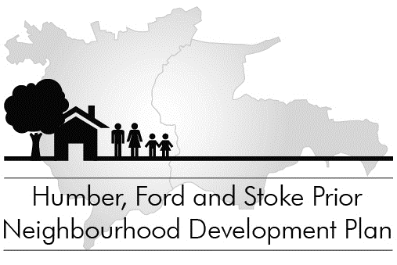

Regulation 14 Public Consultation Notice
In accordance with Neighbourhood Planning (General) Regulations 2012, part 5, 14 (a)-(c), notice is hereby given that a formal pre-submission public consultation on the Draft Humber, Ford & Stoke Prior Neighbourhood Development Plan will start at 9.00 am on Saturday 1 August 2015 for a period of six weeks ending at 5.00 p.m. on Tuesday 15 September 2015.
Copies of the draft Plan will be delivered to each household and business in the Group Parish, and are also available:
- On the parish website NDP web-pages: www.hfspgroup.org.uk
- On request from the Clerk to Humber, Ford & Stoke Prior Group Parish Council by email to clerk@hfspgroup.org.uk, or by post to Great Marston Farmhouse, Risbury, Herefordshire HR6 0NJ
- For inspection at Leominster Information Office and the Post Office in Stoke Prior (during opening hours)
Supporting documents and Appendices are available on the parish website NDP web-pages at www.hfspgroup.org.uk
Comments should be sent in writing, and should include the name and address of the person making the comments. As this is a statutory consultation, all comments submitted will be available publicly. A form is available for comments, which will be delivered with copies of the Plan and available on the website.
If you wish to be kept updated on future progress with the Neighbourhood Plan, please also give an email address (which will not be published).
Please make comments as specific as possible, relating to specific Policies. It is important to quote the relevant policy or paragraph number(s).
Send your comments to Humber, Ford & Stoke Prior NDP Steering Group:
by post: The Clerk, Humber Ford & Stoke Prior Group Parish Council, Great Marston Farmhouse, Risbury, Herefordshire HR6 0NJ
or by email: clerk@hfspgroup.org.uk
or by hand: at one of the advertised drop-in sessions.
All comments must be received by 5pm on 15 September 2015. These will be considered by the NDP Steering Committee and will help shape the final Plan to be produced in the autumn. A Consultation Statement, including a summary of all comments received and how these were considered, will be published together with the final Plan.

Philip J Brown
Clerk to the Council
Humber, Ford & Stoke Prior Group Parish Council 25 July 2015

