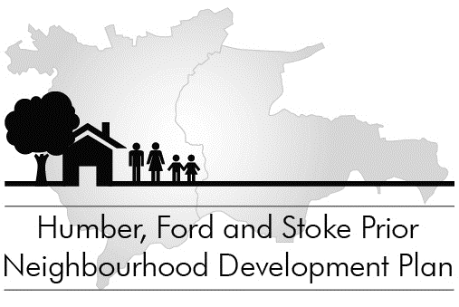
Draft Neighbourhood Plan
Public consultation 1 August – 15 September 2015
Comments sheet

You may use this sheet to submit comments.
Please give your name and address. As this is a formal statutory consultation all comments submitted will be available publicly.
If you wish to be kept updated on future progress with the Neighbourhood Plan, please also give an email address (which will not be published).
Please make comments as specific as possible, relating to specific Policies. It is important to quote the relevant policy or paragraph number(s).
Send your comments to Humber, Ford & Stoke Prior NDP Steering Group:
by post: The Clerk, Humber Ford & Stoke Prior Group Parish Council, Great Marston Farmhouse, Risbury, Herefordshire HR6 0NJ
or by email: clerk@hfspgroup.org.uk
or by hand: at one of the advertised drop-in sessions.
All comments must be received by 5pm on 15 September 2015.

Your details
Name
Address
Email address (if you wish to be kept updated)
Please tick as appropriate: | Resident Local business Local organisation National organisation Agent

Please give your comments overleaf. If you need to continue on an additional sheet, please write your name at the top of each sheet and staple sheets together.
Comments on specific policies
If you would like to comment on a specific policy, please state the policy number (and if appropriate any specific paragraph number).
Policy No. | Para No (if applicable) | Comments and/or suggested changes
HFSP

HFSP

HFSP

HFSP

HFSP

General comments

Thank you!

