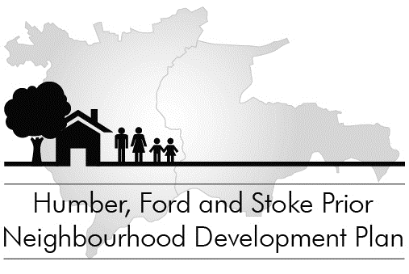
LAND FOR POSSIBLE FUTURE DEVELOPMENT
SURVEY
If you own land or redundant buildings in our Group Parish which might be suitable for some kind of development in the future, please would you complete and return this survey in the small envelope marked ‘Development Land Survey’. If this does not apply to you, there is no need to complete or return this form.
Your completed Development Land Survey will go directly to our independent external planning consultant at Data Orchard and will be treated in strict confidence, but it will subsequently be seen by the members of the Steering Committee in order to help with the drafting of our Neighbourhood Development Plan and they will also treat the information in strict confidence. Completing this form does not commit you to any future action and some possible sites may not turn out to be suitable because of access, drainage or other problems.

1. Do you own land and/or redundant buildings in our Group Parish which you (or a future owner) might consider suitable for some kind of development in the future?
YES (please complete sections 2 to 6 below)
- NO (there is no need to complete and return this form)
2. If you have answered ‘yes’ in section 1 above, please fill in your details:
Name:
Address:
Contact telephone:
Contact email:
Please turn over...
3. Where is the land or buildings which might be suitable for development?
Address (If different from above):

Please give a brief description where this land or buildings might be found:

4. Please give a rough idea of the amount of land involved
acres or hectares
5. How do you think this land might best be developed?
(e.g. small business, dwellings, agricultural buildings, public facility, parking)
Likely usage:

6. Are you likely to consider applying for a change of use in the next (tick one):
3 years 6 years 10 years leave it to the next owner
If you have other plots or buildings which might be considered for development please give the relevant details below (use a blank sheet if necessary):

If you have any questions or need clarification of any point please contact the Parish Clerk at clerk@hfspgroup.org.uk or the Parish Council Chairman at chairman@hfspgroup.org.uk or Peter Lefroy-Owen / Hugh Fowler-Wright (see the main questionnaire for details).

