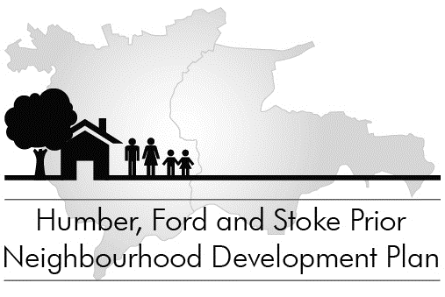

YOUNG PEOPLE’S QUESTIONNAIRE
[5 – 14 years]

Please say just what you think and don’t put your name on the paper.

1. Are you a boy or girl? Girl ☐ Boy ☐
(Tick one)

2. How old are you?

3. About how long have you been living around here?

4. Did you go to Nursery School? Yes ☐ No ☐

If so, where?

5. What do you think about the number of houses around your home?
(Tick one)

Too many ☐
About right ☐
Need a few more ☐
Need lot’s more ☐

Please turn over

6. Would you like to go on living round here when you are grown up?
(Tick one)
Yes ☐ No ☐

7. What are the things you specially like about living round here?

8. What are the things you do not like about living round here?

9. What things would you like to see round here but which are not here now?

10. Write your comment here on anything about living round here which you have not already written about above

