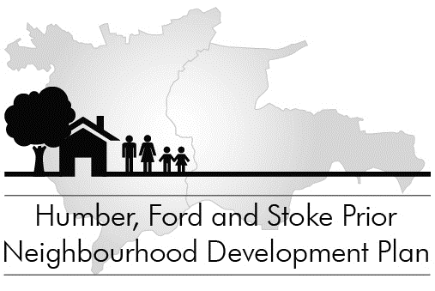

Your Community, Your Future

Free barbecue

Saturday 12 April from 3.00pm
in Humber Close

Come to a special event for residents of Humber Close. This is your chance to discuss what should be in the Neighbourhood Development Plan with other members of the community and the Plan Steering Committee, over a free barbecue (bring your own drinks).

The focus of the afternoon is a big map of the Parish in which you can stick themed flags, marking what matters to you and where. There are also themed boards to pin-up your more detailed comments.

Bring the whole family – it’s your community
and your future!

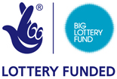

Your Community, Your Future

Free barbecue

Saturday 12 April from 3.00pm
in Humber Close

Come to a special event for residents of Humber Close. This is your chance to discuss what should be in the Neighbourhood Development Plan with other members of the community and the Plan Steering Committee, over a free barbecue (bring your own drinks).

The focus of the afternoon is a big map of the Parish in which you can stick themed flags, marking what matters to you and where. There are also themed boards to pin-up your more detailed comments.

Bring the whole family – it’s your community
and your future!

