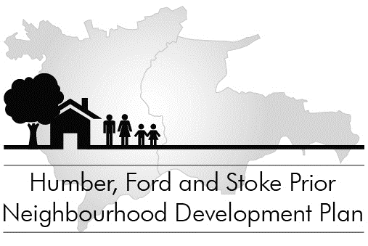

Your Community, Your Future

You told us you wanted a Neighbourhood Development Plan. We’ve been setting up the project and now it’s time for you to get involved.

What development does our community need?
Where should new housing be built?

Come and have your say - help design the Plan – drop-in on

Friday 11 April between 7 and 9pm Blencathra, Fairmile

(by kind permission of John and Madeleine Townsend)

The focus of the evening is a big map of the Parish in which you can stick themed flags, marking what matters to you and where. There are also themed boards to pin-up your more detailed comments.

Discuss what should be in the Neighbourhood Development Plan with other members of the community and the NDP Steering Committee.

- Free drinks and nibbles
Bring the whole family - it’s your community and your future!

